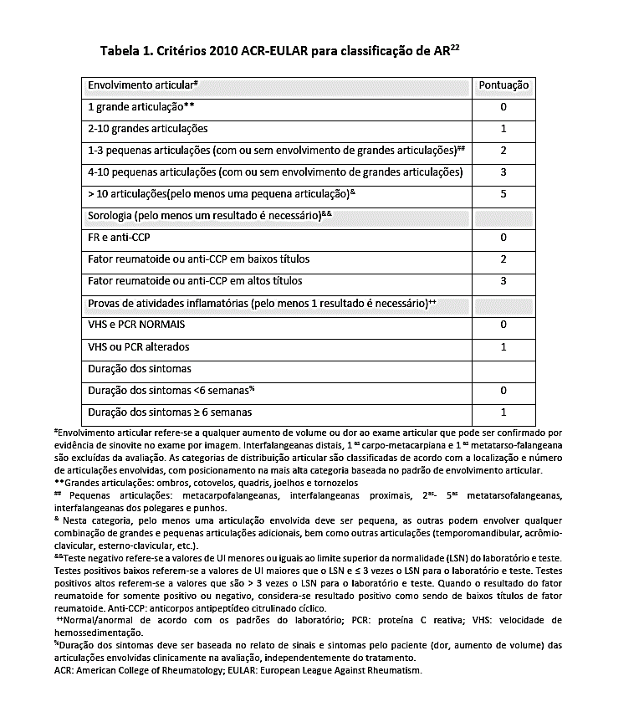

**TOTAL**: _______